**JAVA-FSD (PHASE-1)**

**LockedMe – Virtual Key for Repositories**

Developer details:-

Ritik

Technical Trainee

TEK System Global Services

Link to this project: <https://github.com/Rkcr7/LockedMe.com>

**PROJECT DESCRIPTION**

**Project objective:**

As a Full Stack Developer, complete the features of the application by planning the development in terms of sprints and then push the source code to the GitHub repository. As this is a prototyped application, the user interaction will be via a command line.

**Background of the problem statement:**

Company Lockers Pvt. Ltd. hired you as a Full Stack Developer. They aim to digitize their products and chose LockedMe.com as their first project to start with. You’re asked to develop a prototype of the application. The prototype of the application will be then presented to the relevant stakeholders for the budget approval. Your manager has set up a meeting where you’re asked to present the following in the next 15 working days (3 weeks):

* Specification document - Product’s capabilities, appearance, and user interactions
* Number and duration of sprints required
* Setting up Git and GitHub account to store and track your enhancements of the prototype
* Java concepts being used in the project
* Data Structures where sorting and searching techniques are used.
* Generic features and three operations:
  + Retrieving the file names in an ascending order
  + Business-level operations:
    - Option to add a user specified file to the application
    - Option to delete a user specified file from the application
    - Option to search a user specified file from the application
    - Navigation option to close the current execution context and return to the main context
  + Option to close the application

The goal of the company is to deliver a high-end quality product as early as possible. 

**The flow and features of the application:**

* Plan more than two sprints to complete the application
* Document the flow of the application and prepare a flow chart
* List the core concepts and algorithms being used to complete this application
* Code to display the welcome screen. It should display:
  + Application name and the developer details
  + The details of the user interface such as options displaying the user interaction information
  + Features to accept the user input to select one of the options listed
* The first option should return the current file names in ascending order. The root directory can be either empty or contain few files or folders in it
* The second option should return the details of the user interface such as options displaying the following:
  + Add a file to the existing directory list
    - You can ignore the case sensitivity of the file names
  + Delete a user specified file from the existing directory list
    - You can add the case sensitivity on the file name in order to ensure that the right file is deleted from the directory list
    - Return a message if FNF (File not found)
  + Search a user specified file from the main directory
    - You can add the case sensitivity on the file name to retrieve the correct file
    - Display the result upon successful operation
    - Display the result upon unsuccessful operation
  + Option to navigate back to the main context
* There should be a third option to close the application
* Implement the appropriate concepts such as exceptions, collections, and sorting techniques for source code optimization and increased performance

**You must use the following:**

* Eclipse/IntelliJ: An IDE to code for the application
* Java: A programming language to develop the prototype
* Git: To connect and push files from the local system to GitHub
* GitHub: To store the application code and track its versions
* Scrum: An efficient agile framework to deliver the product incrementally
* Search and Sort techniques: Data structures used for the project
* Specification document: Any open-source document or Google Docs

**Following requirements should be met:**

* The source code should be pushed to your GitHub repository. You need to document the steps and write the algorithms in it.
* The submission of your GitHub repository link is mandatory. In order to track your task, you need to share the link of the repository. You can add a section in your document.
* Document the step-by-step process starting from sprint planning to the product release.
* Application should not close, exit, or throw an exception if the user specifies an invalid input.
* You need to submit the final specification document which includes:
  + Project and developer details
  + Sprints planned and the tasks achieved in them
  + Algorithms and flowcharts of the application
  + Core concepts used in the project
  + Links to the GitHub repository to verify the project completion
  + Your conclusion on enhancing the application and defining the USPs (Unique Selling Points)

## 

## Sprints planning

The project is planned and completed in a single sprint.

Tasks completed in Sprint:-

* Creating the flowchart to determine the flow of the program
* Initializing git environment for project establishment
* Writing java code to fulfill the requirements
* Testing and debugging programs with different inputs
* Pushing code to GitHub.
* Creating this specification document highlighting application capabilities, appearance, and user interactions.

## The flow of the Application

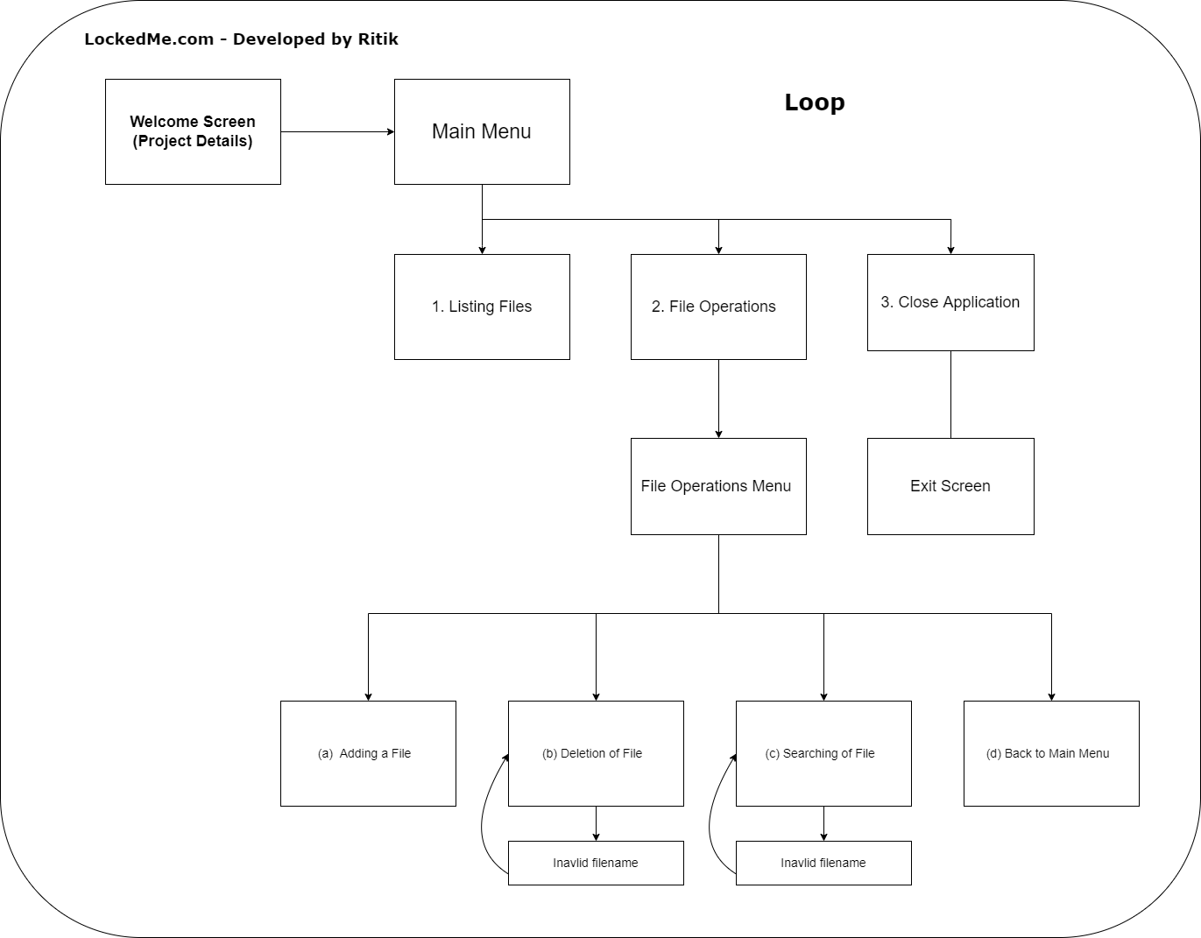

## 

# Demonstrating working of LockedMe.com

**1. Running the application**

* **Welcome screen**
* **Application features**
* **Main menu**

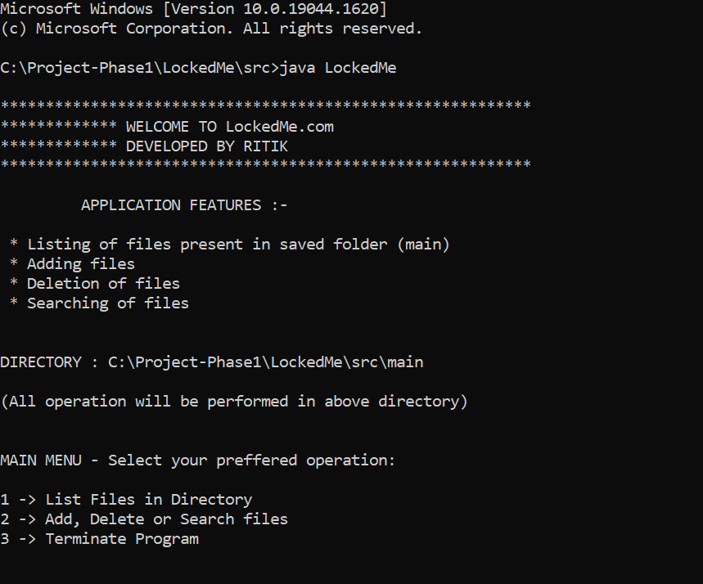

**2.Directory used for file operations**

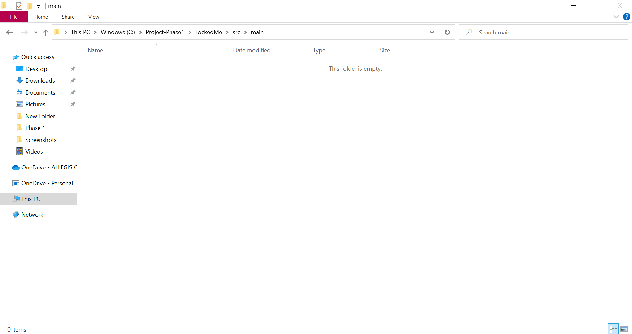

**3. listing file operation with no files present in the directory**

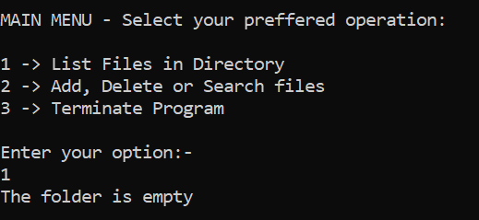

**4. File operation menu**

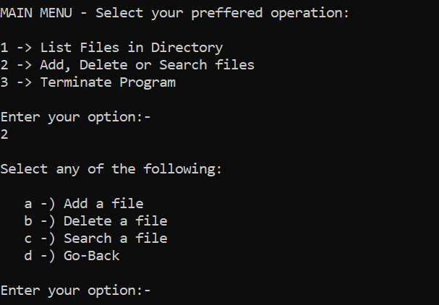

**5. Adding a file**

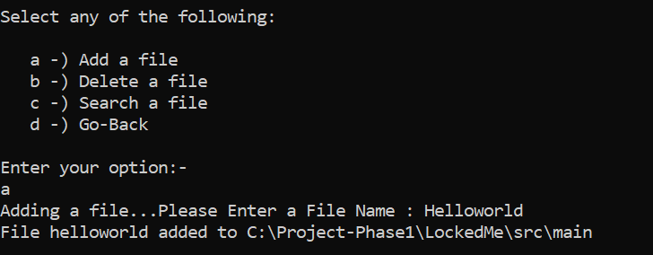

**6. Directory after adding multiple files**

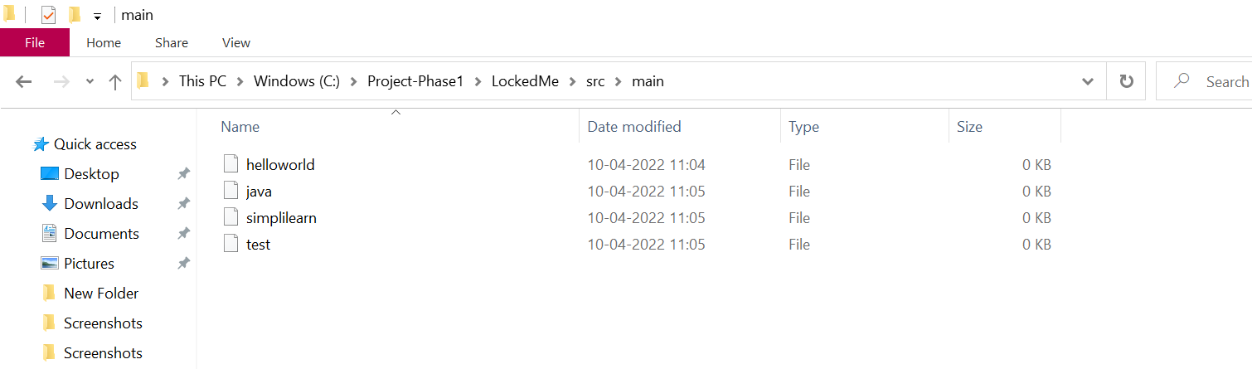

**7. Searching file operation**

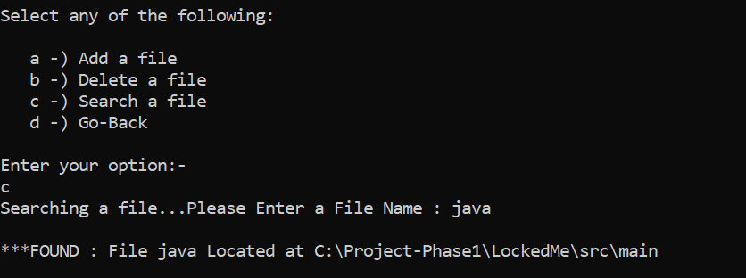

**8. Invalid search name**

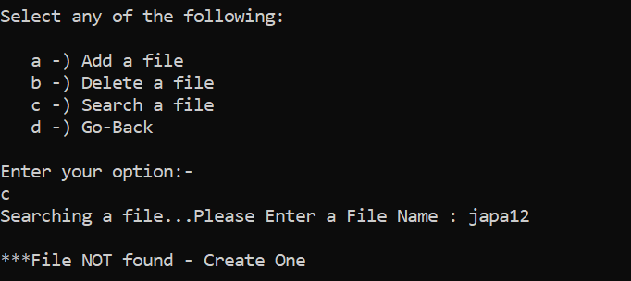

**9. Deletion operation**

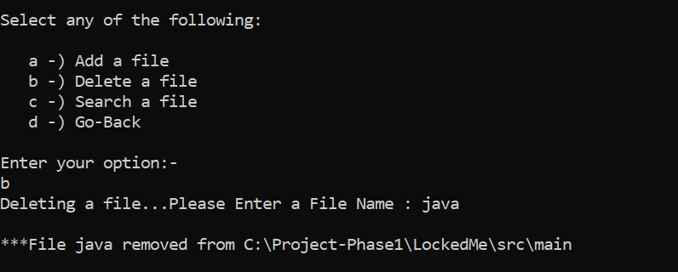

**10. Deleting invalid filename**

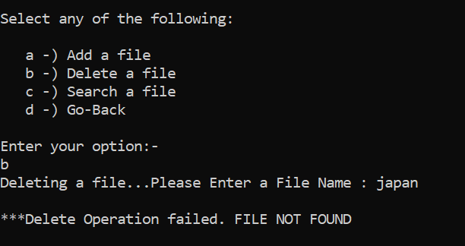

**11. Return to main menu option**

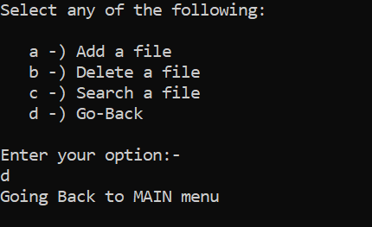

**12. Listing files in directory**

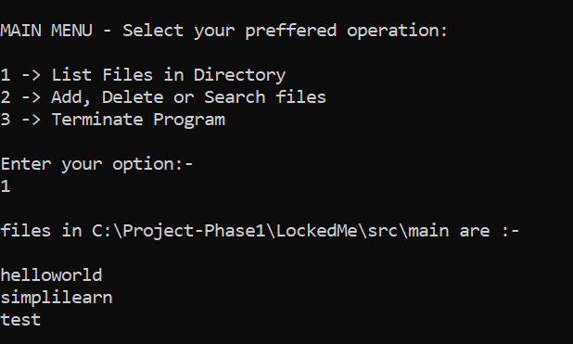

**13. Terminating the program**

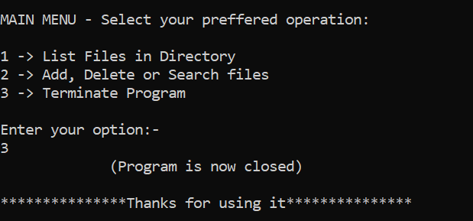

## **Pushing the code to the GitHub repository**

* Initialize repository in project folder using the following command:

**git init**

* Add all the files to your git repository using the following command:

**git add .**

* Commit the changes using the following command:

**git commit . -m “<commit message>”**

* Push the files to the folder you initially created using the following command:

**git push -u origin master**

## **Unique Selling Points of the Application:-**

* User friendly interface – instructions given at every step.
* Working directory is automatically created at the program location
* Users can easily switch between options and revert to previous menus even after performing all necessary operations such as adding, searching, deleting, and retrieving files.
* The java code itself is written in a user-friendly way so it can be modified according to client needs.

## **Conclusions:-**

What more can be done:

* Adding regex feature so that users can easily search for a file without even typing its full name and searching with just a few keywords.
* User confirmation before executing the operations.
* Retrieving files/folders by different criteria like Last Modified, Type, etc.